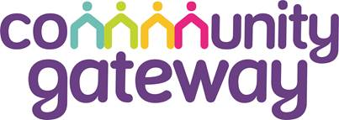

ANNUAL GENERAL MEETING

SATURDAY 13TH SEPTEMBER 2025 – HARBOUR HOUSE

ARRIVAL FROM 11AM
FORMAL AGM STARTS AT 11.45AM

AGENDA
1. | Introductions
2. | Apologies for Absence
3. | Approval of the Minutes of the Annual General Meeting held on 14th September 2024 | Resolution 1
4. | Annual Report Update
5. | Approval of the Directors’ Report and Financial Statements for the period ending 31st March 2025 | Resolution 2
6. | Appointment of Statutory Auditor | Resolution 3
 | Approve the appointment of Beever and Struthers as auditors for the forthcoming year.
7. | Amendment to CGA Rules  Approve the amendments to paragraph B15 of CGA’s Rules.  Approve the amendments to paragraph D6.4 of CGA’s Rules.  Approve the amendments to paragraph D13.1 of CGA’s Rules.  Approve the amendments to paragraph E1 of CGA’s Rules. | Resolution 4.1  Resolution 4.2  Resolution 4.3  Resolution 4.4
 | (Please see the explanatory note for further detail on these changes.)
8. | Approval of Appointment of Association Board Members
 | Approve the appointment of Sue Sutton as an Independent Board Member.  Approve the appointment of Lisa Breeze as an Independent Board Member.  Approve the appointment of Simone De La Harpe as a Tenant Board Member.  Approve the appointment of Stuart Flynn as a Tenant Board Member.  Approve the reappointment of Pam Watson as a Tenant Board Member.  All proposed by Phillip Parramore (Chair of the Board) | Resolution 5.1  Resolution 5.2  Resolution 5.3  Resolution 5.4  Resolution 5.5
9. | Approval of progress against the Community Empowerment Strategy | Resolution 6
10. | Date of the next Annual General Meeting
 | Saturday 12th September 2026.

